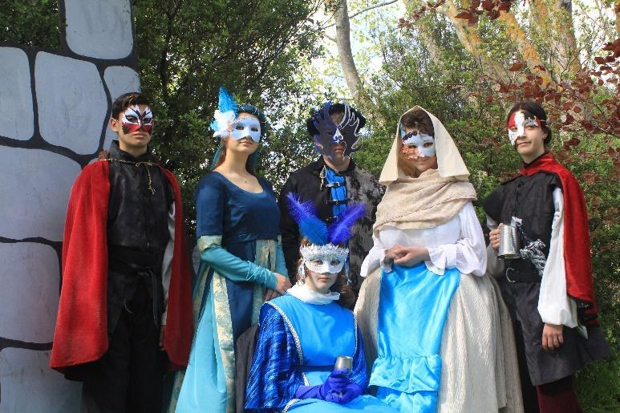
Waikato Waldorf School Charter
Strategic Plan 2020 -2022 & Annual Plan 2022

Waikato Waldorf School is an established, State Integrated Primary and Junior High School.
It caters for students in Years 2-10 from the local town and surrounding rural areas and is set on a spacious organic site.
The school is affiliated to Steiner Education Aotearoa NZ (SEANZ)

Principals’ endorsement | Rob Shirlow
Board of Trustees’ endorsement: | James Herbert
Submission date to Ministry of Education: | March 2022

